Kent Family Justice Board Child Care Conference

Hosted by



Wednesday 13th November 2024
At Canterbury Christ Church University, Augustine Hall, Chaplaincy Centre, N Holmes Rd, Canterbury, CT1 1QN

£45 Per Person (incl.VAT)

Please complete this form before making payment and email it to: Finance@invicta.law

Name
Job title
Organisation
Address
Telephone
Email address
Number of places required
Name(s) and title of additional person(s)

Email addresses of additional person(s)
Please specify any access requirements
Please specify any dietary requirements
How did you hear about this event?
Please make payment by BACS using the following details:  (Please quote your surname and the number of delegates as reference) |  |  | Account Name: Invicta Law Office Account  Sort Code: 60-60-08  Account Number: 56120842

- Please note that tickets to the conference are non refundable

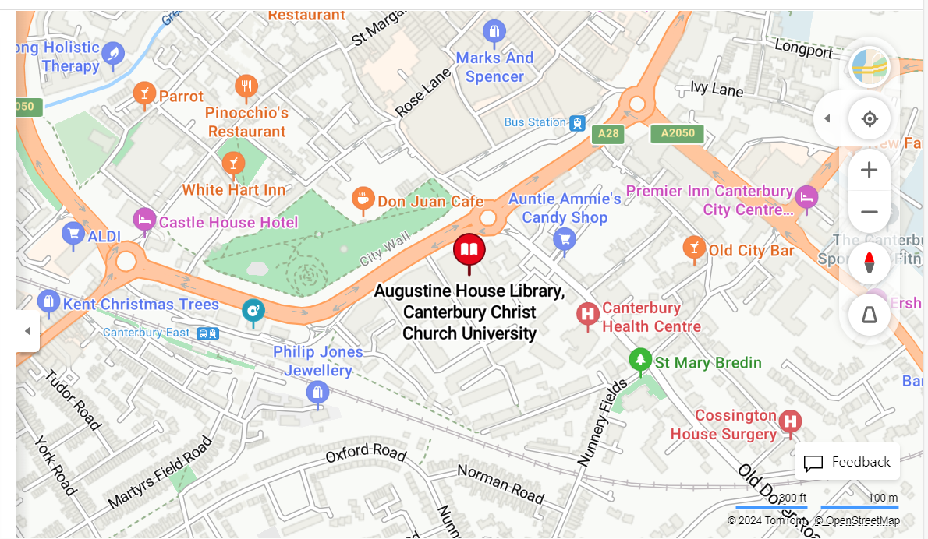

Venue

Augustine Hall is a large, flexible, lecture hall that hosts public lectures and concerts throughout the year. There is step-free access to the lecture hall and accessible toilet facilities on the premises.
Located at the back of the ground floor of Augustine House, the venue is conveniently located close to the city centre and within a 5 minute walk from Canterbury East train station.

Travel

By car
There are several car parks in Canterbury - https://www.canterbury.gov.uk/parking-and-roads/find-somewhere-park

By rail / on foot
The closest train station to Augustine House is Canterbury East.
Invicta Law
Privacy Notice

This Privacy Notice explains what personal information (data) about you we, Invicta Law, will hold, how we collect it, and how we will use that information. We are required to notify you of this under data protection legislation. Please ensure that you read this Notice and any other similar Notice we may provide to you from time to time when we collect or process personal information about you. Invicta Law is a company incorporated in England and Wales with company number 10079679 and its registered office is at 1 Abbey Wood Road, Kings Hill, West Malling, Kent, ME19 4YT. Our Data Protection Officer is Peter Baldock. He can be contacted by email at info@invicta.law or by letter at Invicta Law, 1 Abbey Wood Road, Kings Hill, West Malling, Kent, ME19 4YT.

Data protection principles
We will comply with the data protection principles when gathering and using personal information, as set out in our data protection policy.

What personal information is collected
We may collect the following information about you as a client or potential client:-
- Name and job title
- Contact information, including email address and telephone number
- Demographic information such as postcode, preferences and interests
- Usage of our website
We do not collect special category data from clients or potential clients.

How personal information is collected
We collect information about you when you contact us or instruct us. We also collect information from you if you voluntarily complete client surveys and provide feedback. Website information is collected using cookies. For further information on cookies please see the cookie policy on our website.

Using your personal information
Personal Information you supply to us may be used in a number of ways, for example:-
- To contact you to provide the legal advice and support which you request
- To verify your identity
- In keeping records of the work we have done
- To improve the products and services we provide
- To send you promotional emails about the services and products we provide, if you so wish
- For fraud prevention
We do not use your personal information for automated decision making. We do not share clients’ or potential client’s personal information with third parties.

Marketing
We would like to send you information about products and services which may be of interest to you. If you consent to being sent such information, you will be free to opt out at any time in the future. When you fill in a form or provide your details on our website, you will see one or more tick boxes allowing you to:
- opt in to receive marketing communications from us by email, telephone, text message or post;
- opt in to receive marketing communications from our third party partners by email, telephone, text message or post.
If you consent to our using your personal information for marketing purposes, you have the right to withdraw that consent at any time by the following means:
- sending an email to info@invicta.law ;
- writing to us at Invicta Law, 1 Abbey Wood Road, Kings Hill, West Malling, Kent, ME19 4YT.
We will not share your information for marketing purposes with any other organisation without your consent.

Legal basis for using your personal information
We have a legitimate interest in providing legal services to clients. We have a legitimate interest in using your personal data as a client as it is necessary for us to do so in order to be able contact you and to provide legal services to you. The processing is of a clear benefit both to us and to you; there is a limited privacy impact on you; and you should reasonably expect us to use your personal data in this business context, in particular as you have provided us with your personal data for this purpose. We also have a legitimate interest in the prevention of fraud, and the prevention of fraud also benefits society more widely. We will rely on your consent, if given, to our using your personal information for marketing purposes.

Your data subject rights
You have the following rights with regard to the personal information we hold on you:
- the right to request a copy of your personal information without charge
- the right to have any inaccuracies in your personal information corrected
- the right to request that we erase your personal information if we were not entitled under the law to process it or it is no longer necessary to process it for the purpose it was collected
- while you are requesting that your personal information is corrected or erased or are contesting the lawfulness of our processing, the right to apply for its use to be restricted while the application is made
- the right to object to the processing of your personal information where we are relying on a legitimate interest to do so and you think that your rights and interests outweigh our own and you wish us to stop
- the right to object if we process your personal information for the purposes of direct marketing
- the right to obtain from us a copy of all personal information which you have provided to us, providing processing of this information is based on your consent or on a contract, and providing the processing is carried out by automated means. Where technically feasible, you can request to have the information transmitted directly to another data controller
- the right not to be subjected to automated decision-making (with some exceptions).
If we request your consent to the processing of your personal data for a specific purpose, you have the right not to consent or to withdraw your consent later. To exercise any of the above rights you should contact our Data Protection Officer at info@invicta.law or write to us at Invicta Law, 1 Abbey Wood Road, Kings Hill, West Malling, Kent, ME19 4YT.

The period for which your personal information will be stored
Information may be held in computer and manual files. We only retain the information for as long as it is necessary to carry out the work you request or as required to be kept by law. Files are retained in accordance with Invicta Law’s Retention Schedule Policy, which is available on our website.

Complaints
If you have any complaint or concern over how your personal information has been or may be used, please contact our Data Protection Officer. You may also complain to the Information Commissioner’s Office. Their telephone number is 0303 123 1113 and their website is www.ico.org.uk.

Changes to this notice
We may change this privacy notice from time to time. If you use our website regularly, please visit this page to check this notice.

